Protective effect of Nerve growth factor against Taxol induced neuropathy
Abstract
Chemotherapy-induced peripheral neuropathy is one of the most distressing side effects of chemotherapeutic drugs. In this study we tried to investigate the preventive effect of nerve growth factor (NGF) on taxol induced peripheral neuropathy. 30 adult male albino rats were used. They were classified into 3 groups (G) (n of each=10),. G1, normal control IP injected with normal saline (1mg/kg daily for 2 weeks), G2 model control group, IP injected with taxol (2mg/kg) on days 1, 3, 5, and 7. G3 was IP injected with rhNGF (10ug/kg daily for 2 weeks) one hour before taxol injection. the collected data were statistically analyzed. In this study taxol injection resulted in significant decrease in SNCV, MNCV and significant prolongation of thermal pain threshold. In addition, there were myelinopathy and axonapathy in the examined sections of sciatic nerve in taxol treated rats. The decrease in SNCV and MNCV was mildly prevented by NGF. The histopathological changes were not prominen in some fibers but others show neuropathy.
Key words : nerve growth factor, taxol, peripheral neuropathy.
Corresponding author: Asmaa Rafat Lotfy.

Introduction
The taxol peripheral neuropathy is an important and often dose-limiting side-effect. The incidence of this peripheral neuropathy is often more than 50% and approaches 90% with some dose regimens (Park et al., 2013).
Nerve growth factor (NGF) is a protein which is important for the growth, maintenance, and survival of certain target neurons . It also acts as a signaling molecule (Marco and Luigi, 2011). It is one of the family "nerve growth factors" or neurotrophins which also include Brain-Derived Neurotrophic Factor (BDNF), Neurotrophin-3 (NT-3), Neurotrophin 4/5 (NT-4/5), ciliary neurotrophic factor (CNTF) and glial-derived neurotrophic factor (GDNF) (Eibl et al., 2012).
NGF may induce peripheral nerve regeneration after injury. Therefore, NGF has therapeutic effect on topical treatment of corneal neurotropic ulcers and muscle healing after strain injury (Ma et al., 2014). NGF is important for the survival and continuation of sympathetic and sensory neurons. These neurons undergo apoptosis in absence of it. Other studies showed that it can cause axonal growth , axonal branching and a bit of elongation(Zhao et al., 2015).
Aim of the work:

Investigate the preventive effect of recombinant human nerve growth factor in peripheral neuropathy induced by taxol.

Materials and Methods
Materials
30 adult male albino rats, 3 months old, (200- 250) gm body weight, were obtained from animal facility, Sohag University. All animals were housed in animal facility, Sohag Faculty of Medicine. The rats were housed in groups of five in metal box cages (20× 32 ×20 cm) at 22°C temperature and normal light\ dark cycle, with open access to standard laboratory diet and tap water. Before study commencement, animals were adapted to diet and housing conditions for one week. The study was approved by Research Ethics Committee considering care and use of laboratory animals.

Paclitaxel (Taxol) (Sigma Aldrich, St. Louis, MO) was dissolved in saline solution 0.9% Nacl at a concentration of 1mg/ml just before using. Recombinant human nerve growth factor (rhNGF) (Sigma Aldrich.) was preserved at -30 °C and then diluted with saline 0.9% at a concentration of 10ug/ml just before using.

Neuropack 2 apparatus (NIHON KOHDEN MEM-7102K) was used for electrophysiological assessment.
Hot plate apparatus (IITC Inc. Model 39) was used for assessment of thermal pain threshold.

Methods
The 30 rats were divided into three groups (G):
G1:10 adult rats were used as a normal control group, and were received daily intraperitoneal (IP) injection of physiological saline (0.9% Nacl) for 4 weeks.

G2: model control group, 20 adult rats, they were IP injected with taxol (2mg/kg) on days 1, 3, 5, and 7.

G3: 10 adult rats, they were IP injected with rhNGF (10ug/kg daily for 2 weeks) and taxol injection (2mg/kg IP on days 1, 3, 5, and 7) after one hour from NGF injection.
Physiological study:
Electrophysiological assessment and hot plate test were done on days 7, 15, 22, 28 from 1st dose of Taxol or saline injection for all groups.
The assessment of sensory nerve conduction velocity:
The rats were narcotized with ketamine 50 mg/kg and back fixed. Needle stimulating electrode was stated into 1-2mm beside sciatic nerve at the sciatic notch and condyle to stimulate the nerve. Recording Needle electrode was stated into rats’ hind muscle to record the nerve-muscle action potentials. Indifferent electrode was placed in between the stimulating electrode and the recording electrode. Supra maximal stimulus is used.
SNCV= distance between stimulation and recording electrode ̸ latency.
Motor nerve conduction study of the tail nerve:
Motor nerve conduction of the tail nerve was performed with two needle electrodes as the stimulating and recording electrodes. The active recording electrode was placed 4–5 cm distal to the base of the tail. The reference recording electrode was placed as far distally on the tail. Motor NCV was calculated by the conventional method: distance divided by the difference between proximal and distal latencies.

Hot Plate Test
Rats were brought into the testing room and a period of acclimatization was provided. The surface of the hot plate was heated to 55ºC.The rats were placed in the testing apparatus and the timer is started. The latency to show a nociceptive response with tail withdrawal was measured with the timer.
Histological examination:
At the end of the experiment, all animals were anesthetized and sciatic nerve was dissected for histological examination.
Transmission electron microscope:
The specimens were put in 2.5% gluteraldhyde for 24 hours. The specimens were prepared for obtained semi thin sections (0.5-1um) by using Reichert super nova ultramicrotome and stained with toluidine blue, examined by light microscope and photographed. The ultrathin section were prepared and stained with lead citrate and uranyl acetate.
Morphometrical study:
The mean axonal diameter was measured in five different fields from each animal on high power field at (400). The digital photos were taken in microscopic photography unit, and analysis of images was done using Image J software (version 1.46r).The mean sciatic nerve axon diameter (d) was calculated by the following formula ( perimeter = πd ) (Vazquez, 2014).
Statistical analysis:
The collected data were statistically analyzed using Statistical Package Social Science (SPSS) version 16. Comparison between groups after the treatment was examined by using unpaired t-test. P< 0.05 was considered statistically significant.
Results
Physiological and statistical results:
There was no mortality in all groups during the experiment. However, salivation, slight agitation and abnormal gait were noticed in 70% of rats treated with taxol.
In this study taxol injection resulted in significant decrease in SSNCV and CMNCV, also it resulted in significant prolongation of thermal pain threshold in G2.
At the 1st week of the experiment, the average SSNCV, CMNCV, thermal pain threshold in G3 were (61.04±2.03 m ̸ s, 53.1±2.4 m ̸ s, 6±0.8 sec respectively). This was statistically insignificant when compared to G1 (62.3±1.3 m ̸ s, 54.9±1.3 m ̸ s, 5.3±0.9 sec respectively) and G2 (60.9±1.8 m ̸ s, 51.8±4.1 m ̸ s, 6.1± 0.8 sec respectively).
At the 2nd week, there was statistically lower levels of the average SSNCV and CMNCV in G3 as compared to G1 (56.2±4.1 m ̸ s, 50.9± 2.6 m ̸ s in G3) versus (60.1±3.3 m ̸ s, 53.7±1.6m ̸ s in G1 respectively) (P=0.04, P=0.01 respectively). In addition, thermal pain threshold was statistically higher in G3 as compared to G1 (6.8 ± 1.6 sec versus 5.7± 0.7 sec respectively) (P=0.03). On the other hand, results of SSNCV, CMNCV in G3 were statistically significant higher than those of G2 (44.7±3.7m ̸ s, 43.6±2.9 m ̸ s in G2) (P=0.0001, P=0.0001 respectively) and thermal pain threshold in G3 was statistically lower than G2 (10.7±3.2 sec) (P=0.0001).
Histological and statistical results:
Light microscopic examination of semithin sections of the sciatic nerve of the adult rats (group 1) revealed that endoneurial connective tissue was scarse and the nerve fibers were densly packed. The myelinated nerve fibers showed regular myelin with minimal enfolding. Some unmyelinated nerve fibers were noticed (fig). Examination of the taxol treated (group 2) revealed some changes in the myelin in the form of degeneration , formation of ovoid bubbles and separation of myelin sheath, also there were numerous small diameter myelinated fibers and some large fibers have thin myelin sheath (fig.). Examination of G 3 revealed deformity in the myelin sheath and some fibers had separation in myelin sheath. Some fibers showed invagination and evagination of myelin sheath.
Morphometrical results:
In this study the mean sciatic nerve axon diameter and perimeter of the myelinated axons were measured. In G1, the mean sciatic nerve axon diameter was 8.5 ± 2.4 um and the mean perimeter diameter was 26.1± 2.8 um. In G2, the mean sciatic nerve axon diameter was 6.2±2.3 um and the mean perimeter diameter was 19.1±3.4 um, they were statistically significant low levels on comparison with G1 (P=0.0001).
However, results of the mean sciatic nerve axon diameter and perimeter in G3 were (8.3±2.5, 25.8±3.2). These results were statistically insignificant as compared to G1.

Table (1): SSNCV results at 1 and 2 weeks respectively after 1st dose of taxol injection.
SSNCV | Group
SSNCV | Group1  Mean±SD | Group2  Mean±SD | Group3  Mean±SD
SSNCV (m\sec)  after1 week | 62.3 ±1.3 | 60.9±1.8  (G2a) | 61.04±2.03
SSNCV (m\sec) after 2 weeks | 60.1±3.3 | 44.7± 3.7* (G2a) | 56.2±4.1*#
* significant at P <0.05 ( compared to group 1)
# significant at P <0.05( compared to group 2 b )
SD standard deviation
Table (2): CMNCV results at 1, 2, 3 and 4 weeks respectively after 1st dose of taxol injection.
CMNCV | Group
CMNCV | G 1  Mean±SD | G 2  Mean±SD | G 3  Mean±SD
CMNCV  (m\s) after 1 week | 54.9±1.3 | 51.8±4.1 | 53.1± 2.4
CMNCV  (m\s) after 2 week | 53.7±1.6 | *43.6 ±2.9 | 50.9± 2.6*
* significant at P <0.05 ( compared to group 1)
# significant at P <0.05( compared to group 2 )
SD standard deviation

Table (3): Thermal pain threshold results at 1, 2, 3 and 4 weeks respectively after 1st dose of taxol injection.
Thermal pain threshold | Group
Thermal pain threshold | G 1  Mean±SD | G 2  Mean±SD | G3  Mean±SD
Thermal pain threshold  (sec)at1wk | 5.3±0.9 | 6.1 ± 0.9  (G2) | 6 ± 0.8
Thermal pain threshold  (sec)at 2 wk | 5.7±0.7 | 10.7±3.2*  G2)) | 6.8 ± 1.6  *#
* significant at P <0.05 ( compared to group 1)
# significant at P <0.05( compared to group 2 b )
SD standard deviation
Table (4): Mean sciatic nerve axon diameter and perimeter
G3  Mean±SD | G2a  Mean±SD | G1  Mean±SD
8.3± 2.5  # | 6.2± 2.3  * | 8.5± 2.4 | axon diameter  (um)
27.1± 2.8  # | 19.1± 3.4  * | 26.1 ± 2.8 | Perimeter  (um)

* significant at P <0.05 ( compared to group 1)
# significant at P <0.05( compared to group 2 b )
SD standard deviation

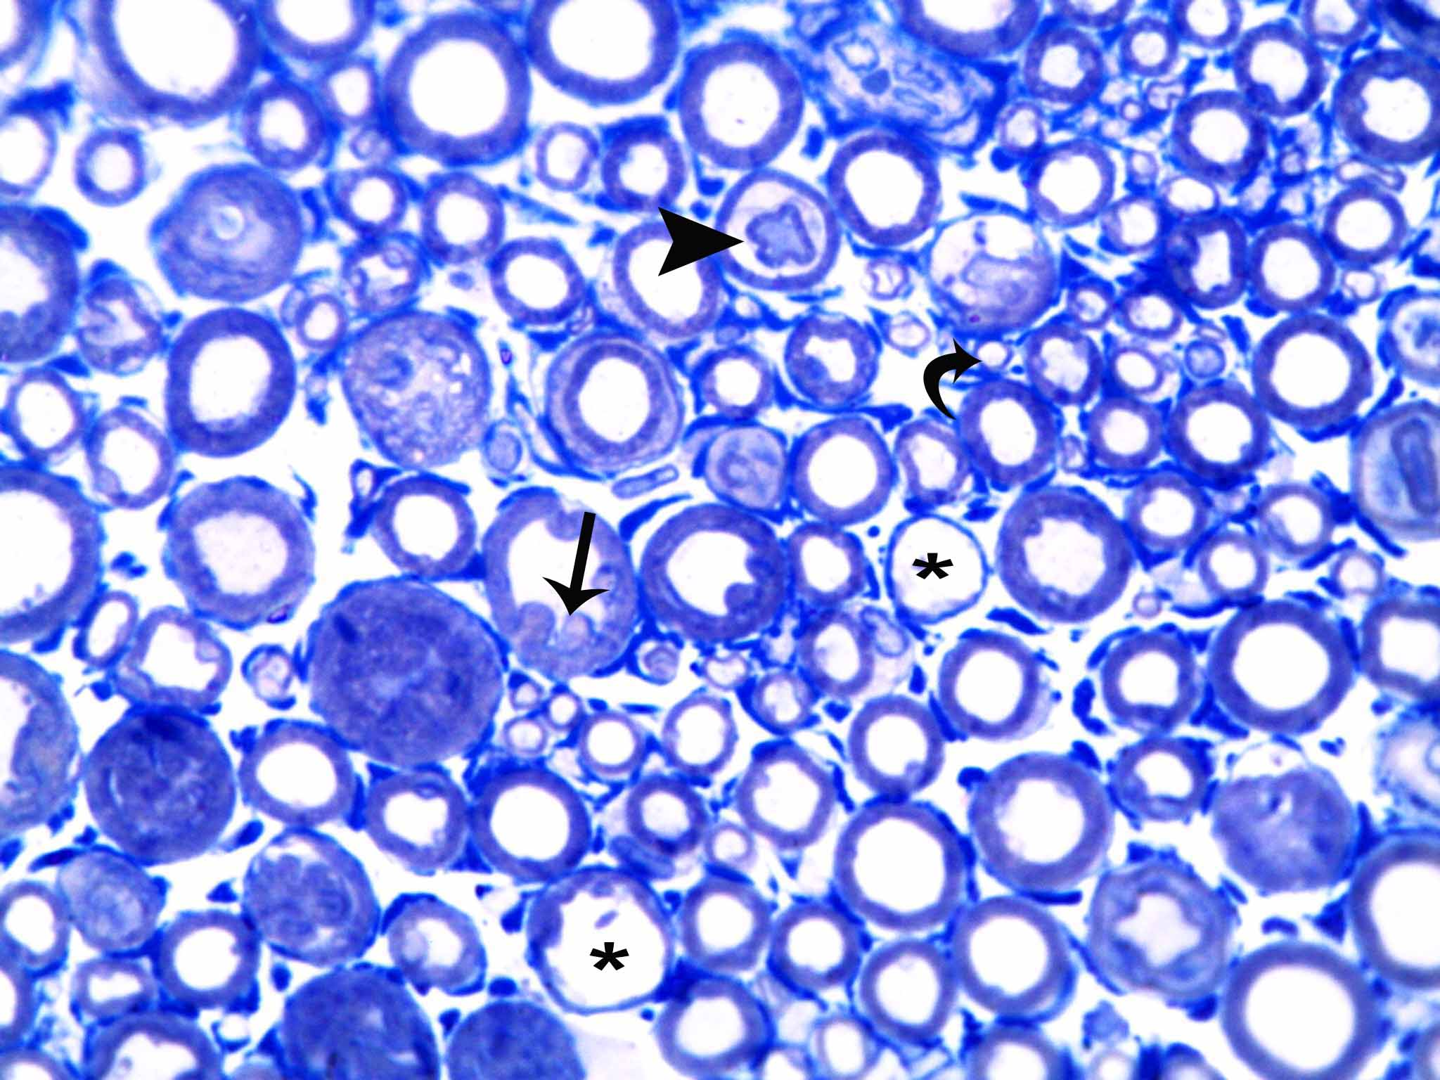
Fig. 17: A photomicrograph of a semithin section of sciatic nerve (G2a) showing degenerated myelinated fibers with formation of ovoid bubbles (arrow). Axonal separation is seen in some fibers (arrow head). There are numerous small diameter myelinated fibers (curved arrow). Some large fibers have thin myelin sheath (*).
(Toludine blue × 1000)

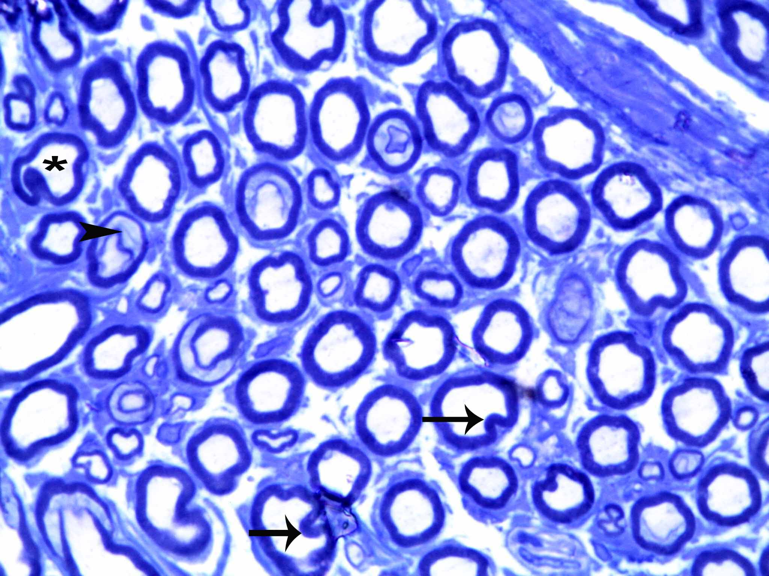
Fig. 19: A photomicrograph of a semithin section of rat sciatic nerve (G3) showing some fibers with deformed myelin sheath (*), others have myelin sheath separation (arrowhead). Some fibers show invagination and evagination of myelin sheath (arrow).
(Toludine blue × 1000)

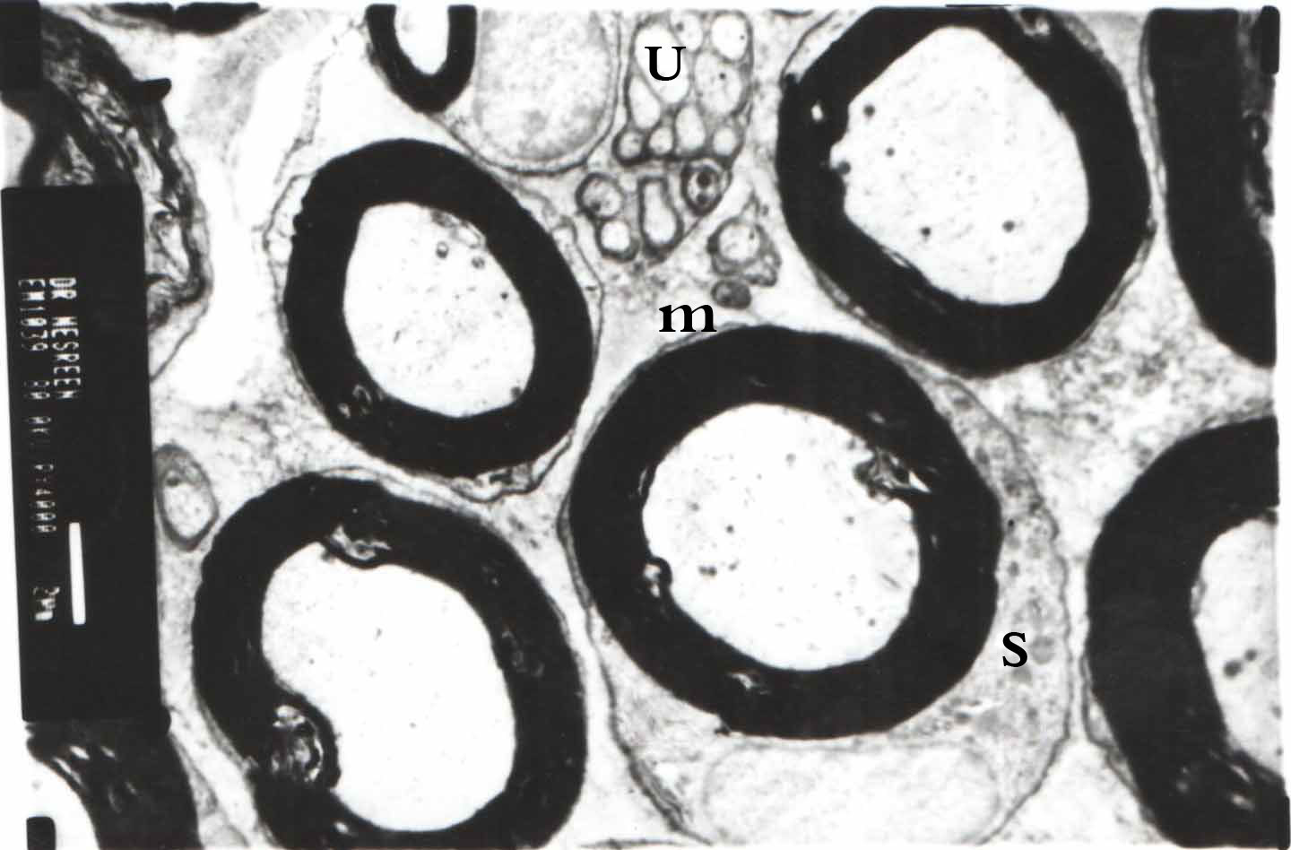
Fig. 23: An electron micrograph of sciatic nerve section of control group (G1) showing myelinated (m) and unmyelinated fibers (u). Schwann cell (s) wraps around a single myelinated axon forming multilayer of myelin sheath.
Uranyl acetate and lead citrate×5000))
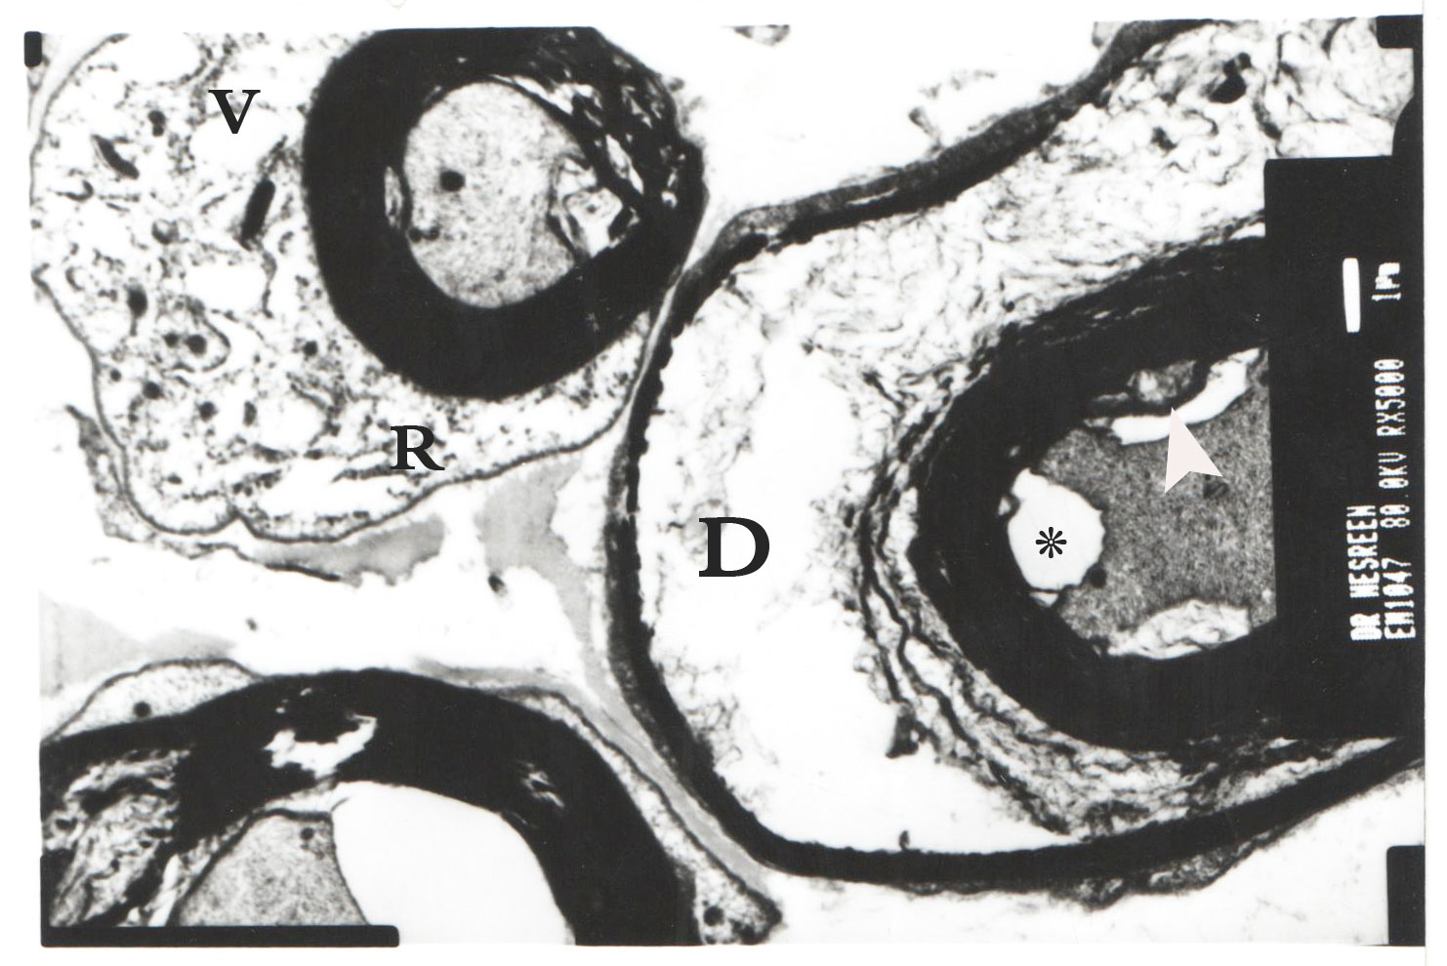
Fig. 25: An electron micrograph of sciatic nerve section of G2a showing ballooning degeneration (D) and splitting in myelin sheath with axon separation (*). Some areas of myelin sheath has pleb (arrow head) within the lamellae between major dense fibers. Schwann cell has dilated RER (R) and vacuoles (v).
(Uranyl acetate and lead citrate×5000)
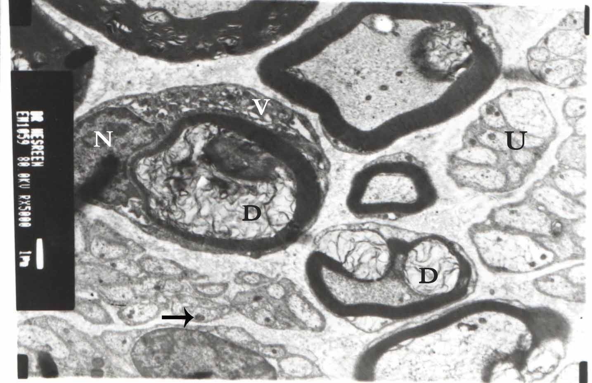
Fig. 28: An electron micrograph of sciatic nerve section of G3 showing unmyelinated axons in random distributed groups (u). They contain electron dense bodies in the axoplasm (arrow). Some myelinated axons still show ballooning degeneration (D) and compressed axon. Schwann cell contains euchromatic nucleus and numerous vacuoles.
(Uranyl acetate and lead citrate×5000)

Discussion
A common complication of chemotherapy is neurotoxicity that often manifests as peripheral neuropathy. Some patients improve once the chemotherapeutic drug is stopped, but as much as 50% of the affected individuals are left with residual peripheral neuropathy that affects their quality of life (Grisold et al., 2012).
Paclitaxel is used for treatment of various cancers, but its deleterious side effects limit its effective and widespread use. One of the most important adverse effects of paclitaxel is peripheral neuropathy (Addington and Freimer, 2016).
In this study, taxol induced neurotoxicity on sciatic and caudal nerves of male albino rats.The albino rats were chosen as the experimental model because it was established that the histological structure of the rats was fundamentally indistinguishable from that of human (Authier et al, 2009). General manifestations of salivation, agitation and abnormal gait were observed in 70% of taxol treated rats. These changes might be due to CNS toxicity. In addition, the abnormal gait could be referred to sciatic nerve degeneration (Nasir et al., 2012).
This study showed that rats treated with taxol had statistically significant decrease in SSNCV and CMNCV compared to control rats. There was statistically significant prolongation in thermal pain threshold compared to control rats. This was in agreement with the previous study of Cengiz et al., 2006 who reported that rats exposed to taxol injection in a dose of 6mg\kg for 3 days showed decrease in NCV. The decrease in SNCV occurred one day after the last injection and continued through seventh and tenth day of their experiment. In addition, they reported decrease in MNCV one day after the last injection which disappeared ten days after the last injection. In another study, there was prolongation in the mean latency, reduction in conduction velocity and amplitude in rats treated with paclitaxel 6mg\kg once weekly for four weeks (Kawa and Dizaye, 2014).

In contrast to our findings, Bardos et al., 2003 reported that rats injected with paclitaxel at a dose of 5 mg/kg for 10 days did not show any changes on MNCV on day 27. Authier et al, 2009 reported that exposure to paclitaxel at a single dose of 16 or 32 mg/kg did not change NCV in vitro. This might be due to the low sensitivity of electrophysiological methods in early detection of neuropathy.
The observed prolongation in thermal pain threshold was in line with Bardos et al., 2003 as they observed that thermal hypoalgesia was not accompanied by morphological or electro-physiological changes. On the other hand Polomano et al., 2001 described an experimental model, showing thermal hyperalgesia, mechanical allodynia and cold allodynia without any dose-response relationship.

The histological findings confirmed the previous results where examination of sciatic nerve observed neurodegenerative changes in both axons and myelin sheath. The axons of the myelinated fibers were compressed with irregular outline. The myelin sheath of affected axons showed degenerative changes as irregular thickening, apparent invagination and evagination. All these results were in accordance with the criteria of toxic neuropathy described by many authors (Makary et al., 2015 and Gerdts et al., 2015 ).
On the other point of view, this decrease in the mean axon diameter could be due to the defect in the myelin sheath production. This was in agreement with previous studies on animal models of paclitaxel and vincristine neuropathy. This might reflect the decrease in nerve conduction velocity in this study and suggest axonal damage (boehemerle et al., 2014).
In G3,there were less deterioration of their SSNCV and CMNCV compared to rats injected with taxol only. There was also increased thermal pain threshold but to lesser extent than recorded in rats injected with taxol only.
As regarding the histological finding, G3 showed that most fibers were still exhibiting degenerative changes in both axons and Schwann cells. Morphometrical and statistical analysis showed a significant increase in the mean axon diameter of the sciatic nerve in both groups compared to the taxol-treated group.
Persistant of degenerative changes inspite of some improvement of physiological changes might be due to the ability of NGF to induce axonal extension and branching. In accordance to these finding, it was stated that NGF could protect against some of the changes of neuronal sensitivity induced by microtubule targeting agents without reversing the morphological changes (Spillane et al., 2013).
These beneficial effects of NGF might be mediated through TrkA signaling. It was suggested that NGF binds to TrkA on a major subset of nociceptive terminals. The NGF/TrkA complex could facilitate the autophosphorylation of the TrkA intracellular domain and subsequent downstream signalling cascade and retrograde transport (Hefti et al., 2006). Also, NGF might be involved in the release and upregulation of neurotransmitters (e.g., substance P, calcitonin gene-related peptide) , sensitization and upregulation of ion channels and receptors present on primary afferent nerve fibres that are implicated in nociception (Pittman et al., 2014).

